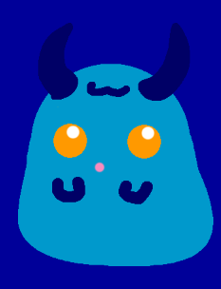

Fav fruit: 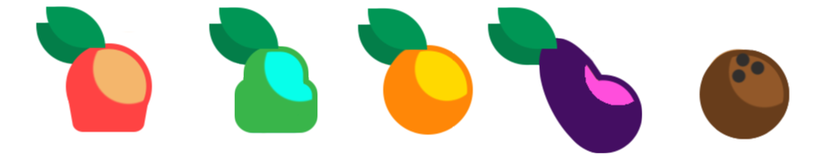

Least fav fruit: 

According to research studies on colour psychology blue is most commonly linked with intellect and logic.

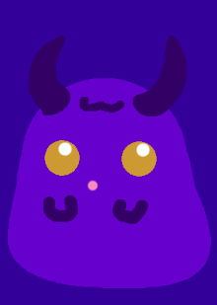

Fav fruit: 

Least fav fruit: 

According to research studies on colour psychology violet links to containment and luxury

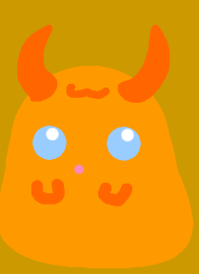

Fav fruit: 

Least fav fruit: 

According to research studies on colour psychology orange links to passion and warmth

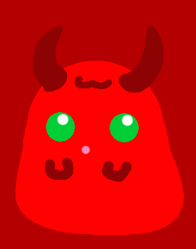

Fav fruit: 

Least fav fruit: 

According to research studies on colour psychology red links to strength and stimulation.



Fav fruit: 

Least fav fruit: 

According to research studies on colour psychology yellow links to confidence and creativity.

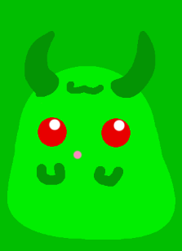

Fav fruit: 

Least fav fruit: 

According to research studies on colour psychology green links to harmony and refreshment.

Refrences:

Colour Affects. (N/A). Psychological Properties Of Colours. Available: http://www.colour-affects.co.uk/psychological-properties-of-colours. Last accessed 04/11/18.